## horizontal line

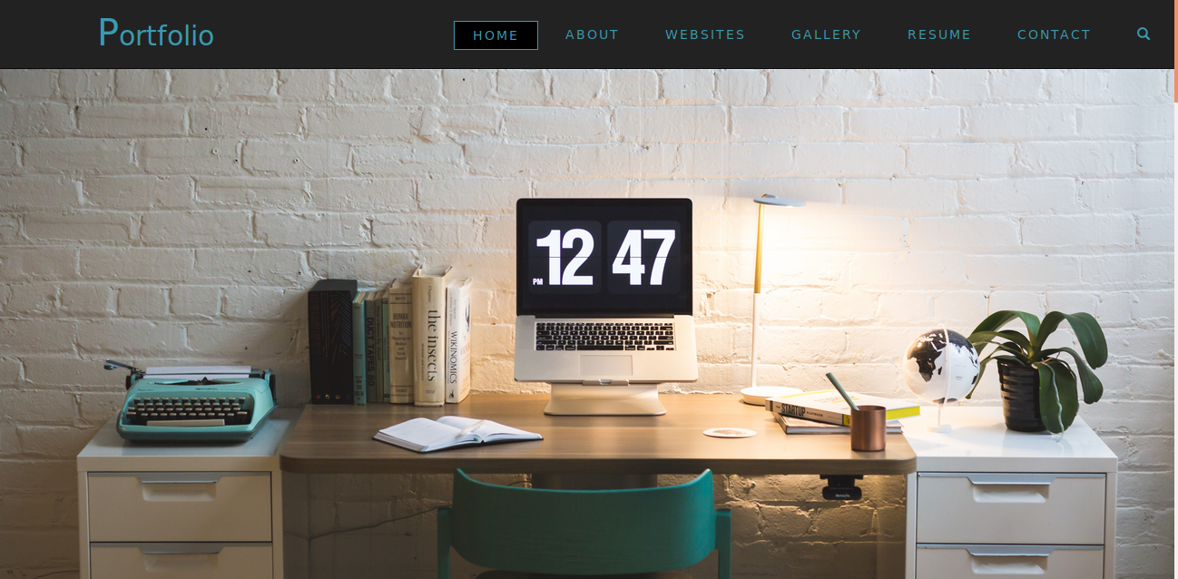

Student Project Portfolio

14.03.2018

**─**

Shilpi Kumari

Karishma Kesari

B.tech CSE

NIET College,

Greater Noida

# Overview

This website is based on the theme Student Project Portfolio. The following languages are used to build : HTML and CSS. The Bootstrap framework is used to make it responsive. This website is helpful for a professional person to represent themselves in a very interactive manner.

# Goals

The ultimate goal of this website is to create a portfolio sample. Such that , any professional employee can share their achievements to community. The high authorities can easily view their page and can download the resume for further references.

# Specifications

The following rules are kept in mind to build up.

1.Integrity

2.Responsive

3.Functionality

4.Creativity

5.Readability

6.Application

# Attachments

The given folder is divided into three folders.

1.Code

1. portfolio.html
2. portfolio.css

2.Images

3.Documentation

# Responsiveness



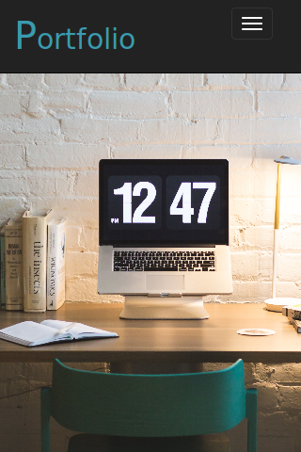 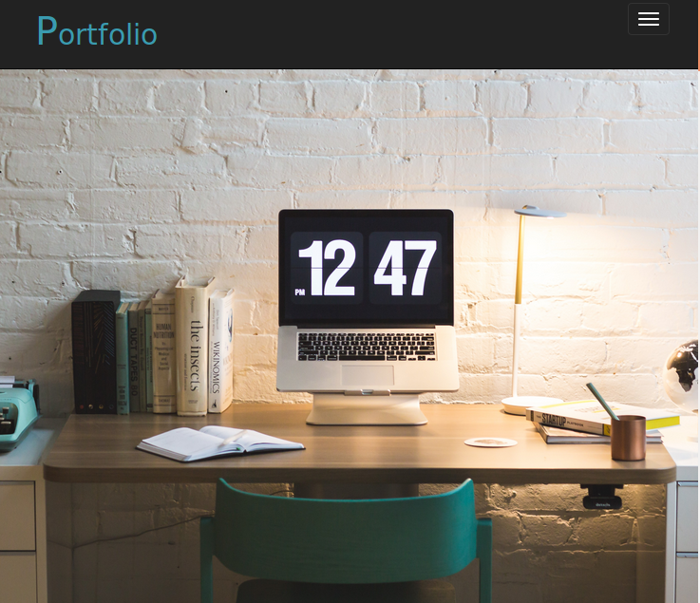

## 

## Thankyou.